# Identify all the different components you know in the following motherboards.

Number 1

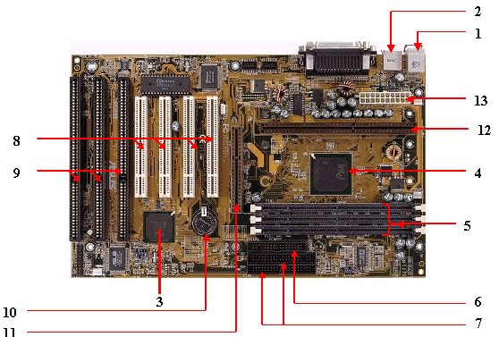

1, 2. External ports

3. Southbridge

4. Northbridge

5. RAM Slots

6. Floppy Controller

7. IDE / ATA Connector

8. PCI Slot

9. ISA Slot

10. CMOS Backup Battery

11. AGP slot

12. CPU Socket (slot 1, *obsolete*)

13. 20-pin ATX Connector

Number 2

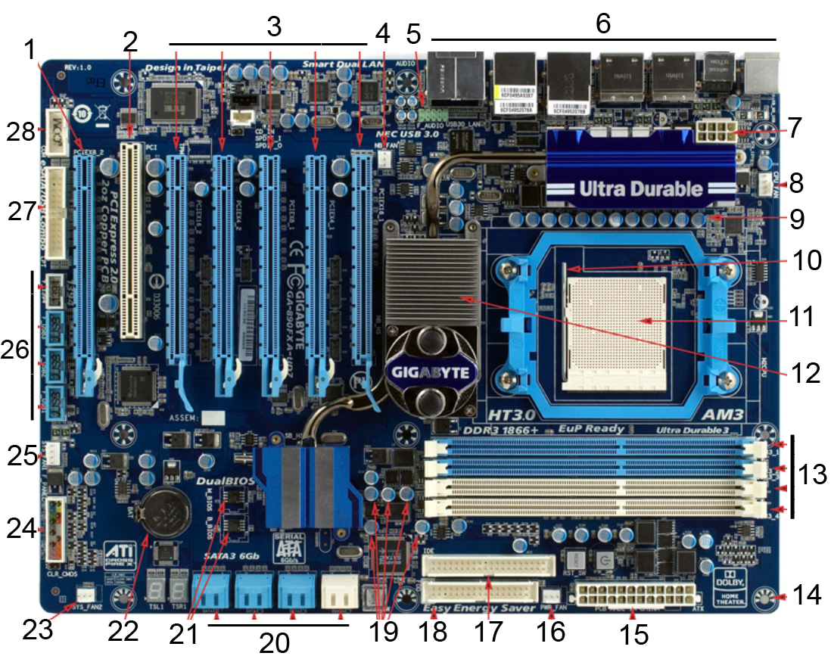

1. PCIe slot

2. PCI Slot

3. PCIe slots x4

4. 3-pin case fan connectors

5. Audio header

6. Back panel and I/O Connections

7. P4 8-pin CPU Power

8. 4-pin CPU fan connection

9. CPU Socket lever

10. CPU Socket

11. Northbridge

12. RAM Slots 4x

13. Mounting screw hole

14. 24-pin motherboard power connector

15. 3-pin fan connector

16. Primary ATA (IDE) Connector

17. Floppy drive connector

18. Capacitors

19. SATA Connections

20. dual BIOS

21. CMOS Battery

22. 3-pin case fan connector

23. System panel connectors

24. 4-pin case fan connector

25. USB connectors x3

26. 1394 header *****

27. eSATA/USB combo header

28. COM Header *****

Number 3

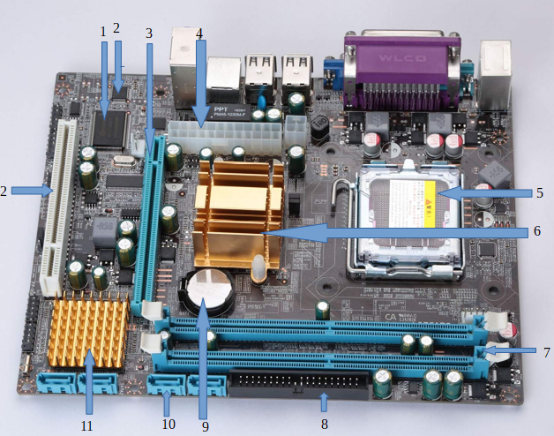

1. Flash Memory (BIOS)

2. CMOS memory

3. PCI Express

4. 20-pin ATX Connector

5. CPU Socket

6. Northbridge

7. RAM Slots

8. IDE / ATA Connector

9. CMOS Backup BAttery

10. SATA Connector

11. Southbridge

12. PCI

Number 4

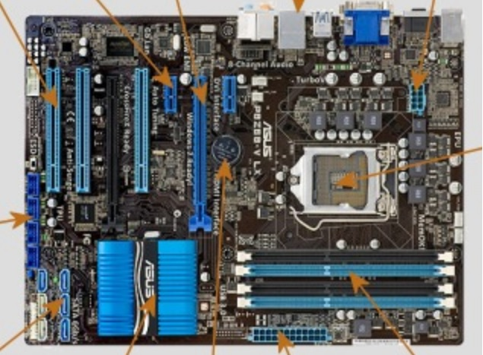

CMOS Backup Battery

24-pin ATX Connector

RAM

DDR3 DIMM

SATA Connector

USB connectors

PCI

PCI express x16

PCI express x1

CPU Socket

Rear panel ports (?)

8-pin ATX Connector

Chipset PCH

Number 5

8-pin ATX Connector

CPU Socket

Heatsink

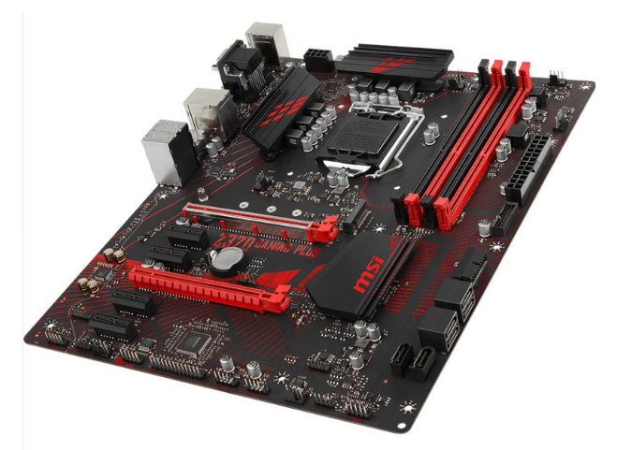

RAM DDR4

24-pin ATX Conector

SATA Ports

PCIe x1

CMOS Backup Battery

Chipset Chipset

PCIe x16

# Identify the external connectors in the following pictures

Number 1

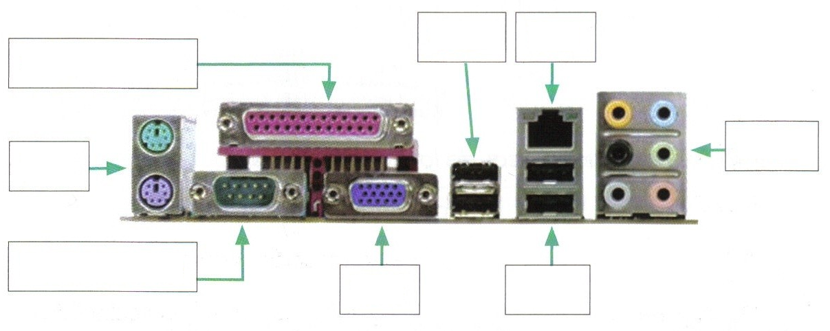

USB

RJ-45

Audio

USB

VGA

Serial

PS/2

Parallel

Number 2

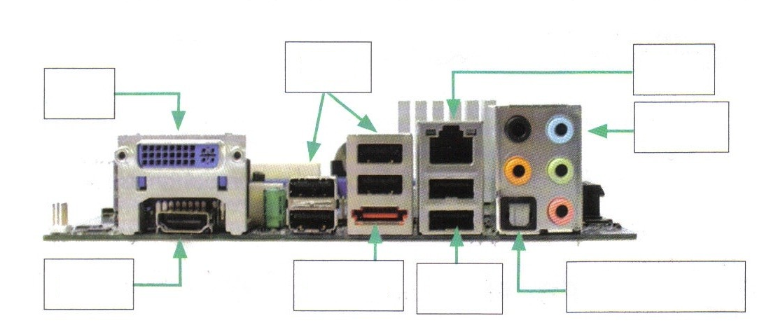

USB

RJ-45

Audio

S/PDIF

USB

eSATA

HDMI

DVI

Number 3

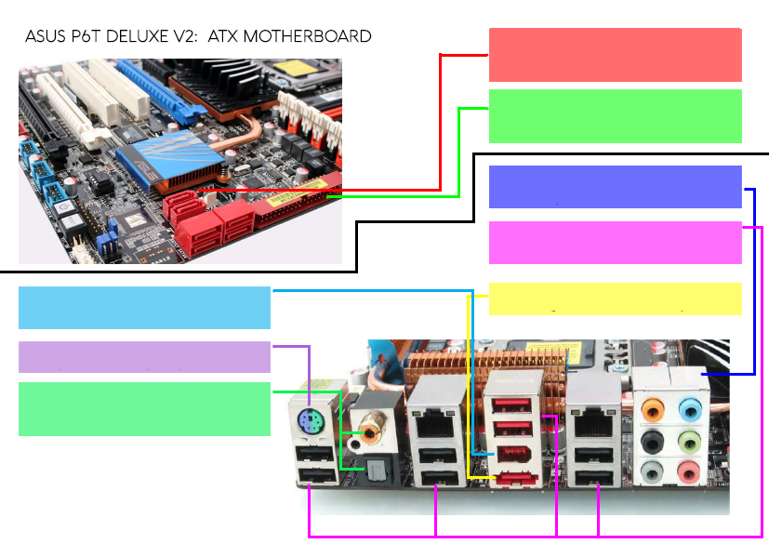

SERIAL-ATA CONNECTORS (SATA 3)

PARALELLATA CONNECTORS (IDE)

JACKS FOR AUDIO

USB 2.0

eSATA PORT

IEEE 1394 (FIREWARE) 6-PIN PORT

PS/2 PORT

SPDIF OUT (OPTICAL and COAXIAL)

Number 4

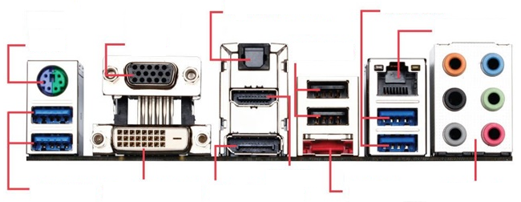

PS/2

VGA

Optical

S/PDIF

USB 3.0

Ethernet

HD Audio

eSATA

HDMI

USB 2.0

DisplayPort

Dual-link DVI

USB 3.0